REAL ESTATE MANAGEMENT SYSTEM

USECASE DIAGRAMS,DATA FLOW DIAGRAMS,TABLE DESIGN

Submitted by

Sachin Vijayakumar

MCA LE S3

Guide in charge

Mrs Ankitha Philip

USECASE DIAGRAMS

1,Normal user

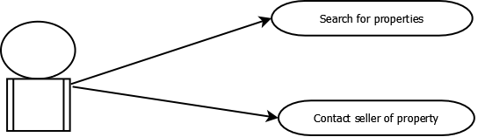

2,Registered user

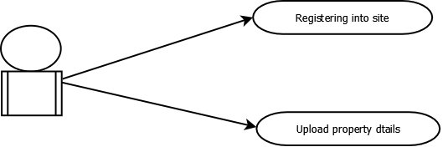

3,Admin

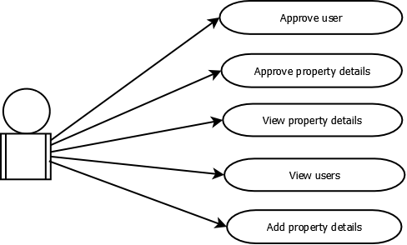

DATA FLOW DIAGRAMS

LEVEL 0 DFD

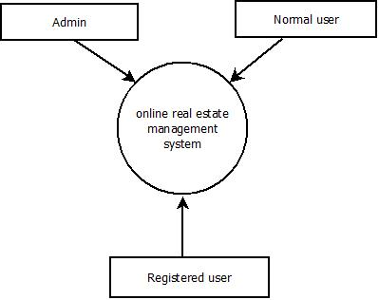

LEVEL1 DFD-NORMAL USER

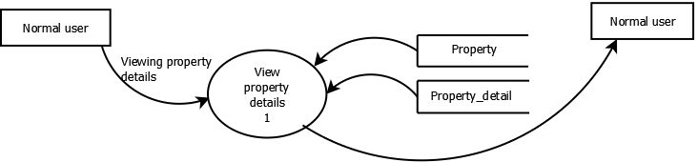

LEVEL1 DFD-REGISTERED USER

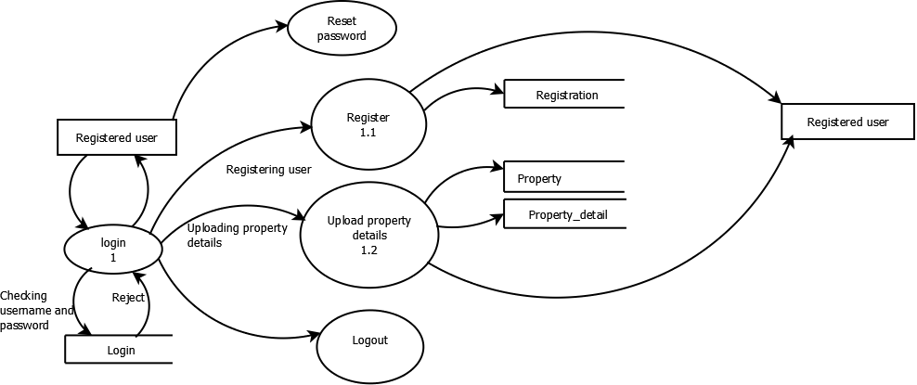

LEVEL1 DFD-ADMIN

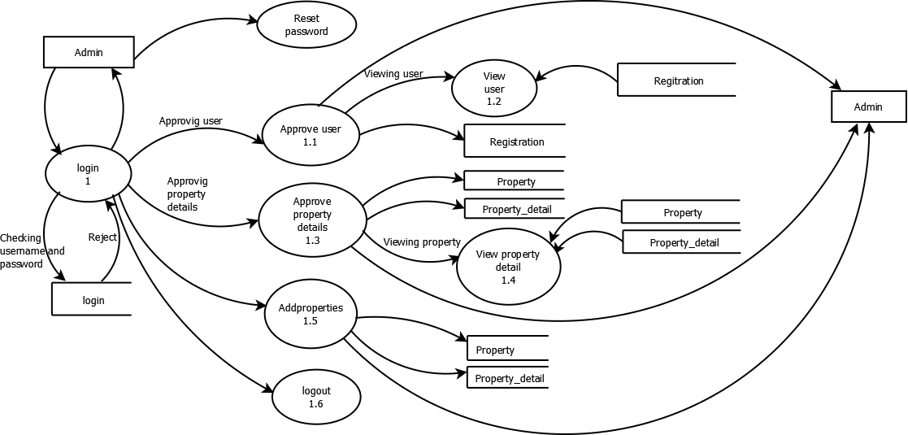

TABLE DESIGN

Table name: login

|  |  |  |  |
| --- | --- | --- | --- |
| Name | type | size | key |
| loginid | int | 10 | Primary key |
| password | varchar | 20 |  |
| type | varchar | 5 |  |
| regid | int | 5 | Foreign key |
| status | int | 5 |  |

Table name:registration

|  |  |  |  |
| --- | --- | --- | --- |
| Name | Type | Size | Key |
| Regid | Int | 5 | Primary key |
| Firstname | Varchar | 30 |  |
| Lastname | Varchar | 30 |  |
| Address | Varchar | 40 |  |
| Email | Varchar | 30 |  |
| Phoneno | Varchar | 10 |  |
| Gender | Varchar | 5 |  |
| Image | Varchar | 30 |  |
| Dob | Varchar | 10 |  |
| Username | Varchar | 20 |  |

Table name:property

|  |  |  |  |
| --- | --- | --- | --- |
| Name | Type | Ize | Key |
| Pid | Int | 5 | Primary key |
| Pname | Varchar | 20 |  |
| Types | Varchar | 20 |  |

Table name:property_details

|  |  |  |  |
| --- | --- | --- | --- |
| Name | Type | Size | Key |
| Kid | Int | 5 | Primary key |
| Pid | Int | 5 | Foreign key |
| Sqfeet | Varchar | 10 |  |
| Photos | Varchar | 20 |  |
| Description | Varchar | 50 |  |
| Roomno | Varchar | 10 |  |
| Area | Varchar | 10 |  |
| Address | Varchar | 50 |  |
| Price | Varchar | 20 |  |
| Loginid | Int | 5 | Foreignkey |
| Country | Varchar | 20 |  |
| State | Varchar | 20 |  |
| District | Varchar | 20 |  |
| Town | Varchar | 20 |  |
| Bedroomno | Varchar | 10 |  |
| Bathroomno | Varchar | 10 |  |
| Electricitybackup | Varchar | 5 |  |
| Swimmingpool | Varchar | 5 |  |
| Playarea | Varchar | 5 |  |